【项目助理】  <Job responsibilities 岗位职责>  *Be an assistant of the project management team to prepare, update and maintain the project management system and process.  协助项目管理团队编制、更新维护项目管理制度及流程；  *Work with project management team to develop project objectives, content, plan, and assist in project monitor, implementation and management.  配合项目管理团队制定项目目标、工作内容、计划，并协助项目监控、执行与管理；  *Assist project management team to follow, summarize the progress and quality of the project. Analyze and evaluate the status of the project, coordinate with the team to solve the problems in the project implementation.  协助项目管理团队跟踪、汇总项目的进度、质量，进行项目状态分析及评估，配合团队反馈并协调解决项目执行中的问题；  *Register the project approvaled in time, submit project statistics report regularly, and report the project status.  及时登记公司审批通过的项目，定期提供项目统计报表，汇报项目情况；  *Cooperate with project team to organize and participate in project management related report, evaluation and summary.  配合项目团队组织并参加项目管理相关的汇报、评审及总结等；  *Work with other departments to do project management and accounting.  与其它部门协作，做好项目管理、核算工作;  <Qualifications 任职资格>  *Senior or Master student, major in Environment and Engineering, Water Supply and Sewerage Engineering.  环境工程、给水排水工程专业本科及研究生;  *Be proactive, optimistic on project execution.  热情上进，执行力强;  *Quick learner and have great readiness to learn.  具有快速学习能力,并且有强烈的学习欲望;  *Team work spirit.  具有团队配合精神;  *Good communication skills.  良好的沟通能力;  *Be enthusiastic and interested in Project management.  对项目管理感兴趣;  *Good at MS Office.  熟练使用办公软件; | 【销售工程师】  <Job responsibilities 岗位职责>  *Visit customers and collect the information and demand.  搜集客户信息，拜访客户，了解客户需求;  *Participate in the company's existing projects, cooperate with the project department and other salers to complete the project.  参与公司现有项目，配合项目部及其他销售人员完成项目；  *Participate in the staff development plan, achieve self promotion according to complete the learning task and training.  参与员工发展计划，按照既定规划及培训，完成学习任务，获得自我提升；  *Visit customers to catch the demand and information under the guidance of the old salers.  与老销售一起拜访客户，了解客户需求，学习销售与沟通技巧；  *Review and summarize regularly to develop good work habits, form good work ideas.  定期回顾和总结项目及客户需求，形成良好的工作习惯，养成工作思路；  *Learning the LeakView, WaterView and other equipments, have an intimate knowledge of business.  了解及学习WV、LV及硬件设备产品知识，熟悉公司业务；  <Qualifications 任职资格>  *Senior or Master student, major in Environment and Engineering, Water Supply and Sewerage Engineering.  环境工程、给水排水工程专业本科及研究生;  *Be proactive, optimistic on project execution.  热情上进，执行力强;  *Can work under high pressure, positive working attitude.  抗压能力强，工作态度积极;  *Good interpersonal skills, pleasant personality and a team player.  良好的维护人际关系能力;  *Good communication skills.  良好的沟通能力;  *Good at MS Office.  熟练使用办公软件; | 【研发工程师】  <Job responsibilities 岗位职责>  *Cooperate with the project department, according to the survey results to analyze the content of demand.  配合项目部门，根据调研结果对需求调研内容进行分析;  *Complete the programming task assigned by the superior.  完成上级领导分配的开发任务;  *Technical support for the user according to the problems encountered in the process of product use.  根据产品使用过程中用户遇到的难题，进行技术支持;  *Answer the questions from the project manager of each product.  解答各个产品的项目经理提出的产品方面的疑问;  *Complete the study task assigned by the superior.  完成上级领导安排的学习任务;  *Check and test the system function.  对系统功能进行检查和测试;  *Cooperate with the project team to carry out pre sales support.  配合项目部门进行售前支持;  <Qualifications 任职资格>  *Senior or Master student, major in computer science or equivalent.  计算机相关专业本科生及研究生;  *Be proactive, optimistic on project execution.  热情上进，执行力强;  *Quick learner and have great readiness to learn.  具有快速学习能力,并且有强烈的学习欲望;  *Team work spirit.  具有团队配合精神;  *Good communication skills.  良好的沟通能力;  *Be enthusiastic and interested in Programming.  对编程感兴趣;
【项目助理】  职业成长路径：  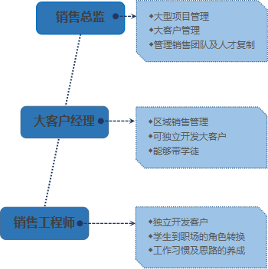  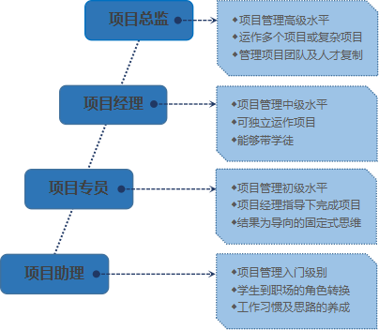 | 【销售工程师】  职业成长路径： | 【研发工程师】  职业成长路径：  